**Ralph In Space – GDD**

**Trailer** - <https://www.youtube.com/watch?v=f4HBViKR74A>

**WebGL HTML5** - <https://www.newgrounds.com/portal/view/807553>

**Intro**

Back in the 60s, during the Space War between the superpower nations.

An astronaut explored the atmosphere and break away from spaceship.

This was Ralph.

Over the years, Ralph did not age at all because of the time dilation.

These days, billionaires from earth are trying to conquer the space.

Ralph lives there and it interferes with their mission.

Various of flying robotic monsters are sent to eliminate him.

Are you able to help Ralph survive?

**Gameplay**

Ralph is in space and flying robotic monsters are trying to kill him with different tactics, Ralph can move with the arrows to escape from monsters and aim and attack them with left click on mouse.

Ralph has 5 lives and can get drops from monsters to heal himself.

Ralph shoot with red lightsaber but can collect drop of blue lightsaber which more stringer and mor faster than the red lightsaber.

There are 2 level with different monsters and then the notorious boss arrives and try to hit Ralph with earth bullets.

**Characters:**

**Ralph**

Health: 5

**Enemies:**

**Green Minion Copter**

Health: 1

Damage: 1

Speed: 8

Time between attacks: 4

**Orange Copter**

Health: 3

Damage: 1

Speed: 20

Time between attacks: 3s

Skill: Close attack

**Blue Ranged Copter**

Health: 10

Damage: 1

Speed: 10

Time between attacks: 4s

Skill: Attack from range

**Heli Summoner**

Health: 4

Damage: 0

Speed: 5

Time between summons: 4s

Skill: summon Green Minion Copter

**Boss Copter**

Health: 20

Damage: 1

Speed: 5

Time between attacks: 2s

Skill: Attack from range

**Camera**

Ralph in Space is a 2D game which is played from one side to another. The hero is in the middle of the camera and it follows when he moves.

**Controllers**

Shoot with mouse, move with arrow keys or WASD.

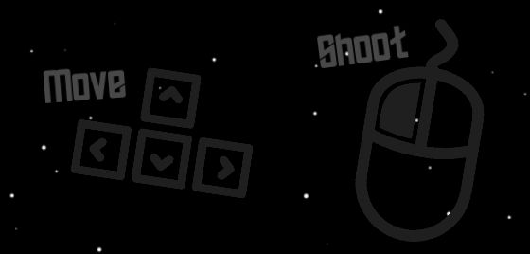

**Weapons**

Red lightsaber is default with damage 1.

Blue lightsaber only from drops with damage 2.

**

**Pickups**

Ralph can gain drops when the enemy is dead, step on object to pick it up.

**

**Scenes**

**Main Menu**

Press “Play” to start the game or “About ” to go to about screen

**About**

Press “Go Back” to go to Main Menu screen

**Level 1**

Enemies: **Green Minion Copter and Orange Copter**

**Level 2**

Enemies: **Blue Ranged Copter, Heli Summoner and Green Minion Copter**

**Boss**

Enemies: **Boss Copter**

**Lose**

Press “Play Again” to start the game or “Back to Menu” to go to main menu screen

**Win**

Press “Play Again” to start the game or “Back to Menu” to go to main menu screen

**Known Bugs:**

* Ralph can not collect drops behind stoppers.
* Resolution is broken sometimes in small screen.
* Text on Boss Copter.
* Location of blue lightsaber sometimes is behind Ralph.
* Location of weapon is inaccurate and shoot not from hand.
* Can collect pickups even you don’t need them.
* No exit button.